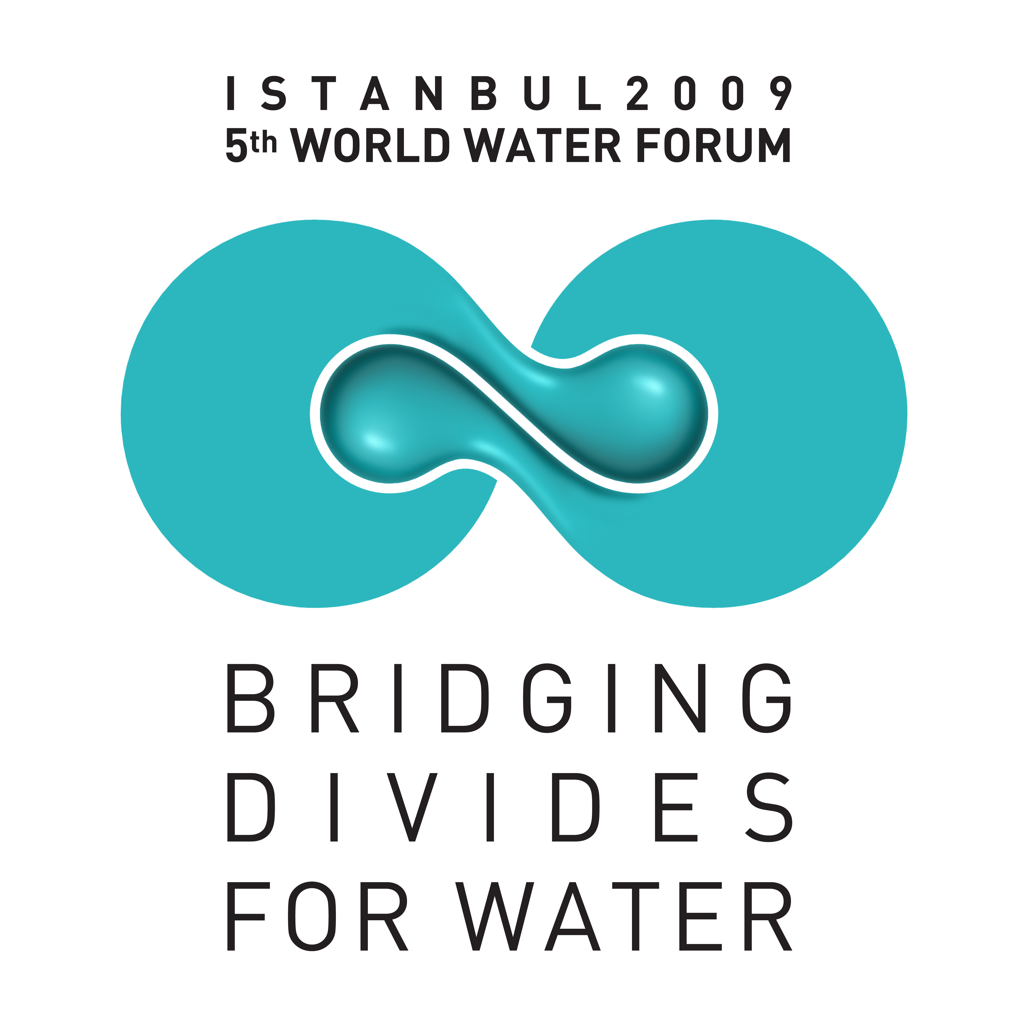


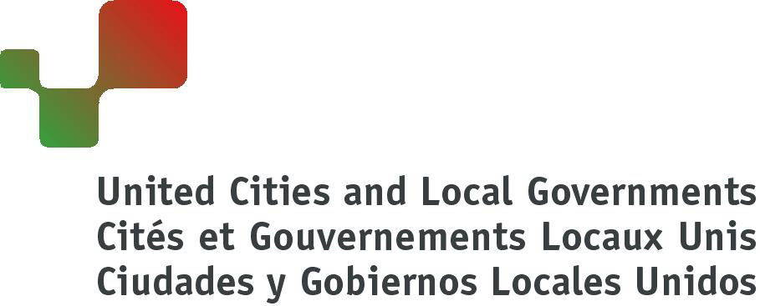
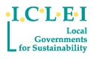

5th World Water Forum

Istanbul Water Consensus

For Local and Regional Authorities

As Mayors and local/regional elected representatives from different parts of the world, meeting in Istanbul in March 2009, we participate in this ISTANBUL WATER CONSENSUS to develop water management strategies in the face of global changes.
On the occasion of the Fourth World Water Forum in Mexico, the Local Government Declaration on Water of 21 March 2006 expressed the awareness and responsibility of local and regional leaders concerning water and sanitation and called on national governments for a more effective partnership.
We build on previous commitments and express our readiness to take leadership in advancing integrated water management approaches to ‘bridge divides for water’ and strengthen the resilience of our cities and regions to cope with rising external pressures and contribute to our overall sustainable development.

PART I – Local and Regional Governments’ Declaration and Call for Action
With this Consensus, we acknowledge that:
- Access to good quality water and sanitation is a basic right for all human beings and plays an essential role in life and livelihoods, the preservation of the health of the population and the fight against poverty;
- Water is a public good and should therefore be under strict public control, independently of whether the services are delegated to the private sector or not;
- Sanitation is equally important as water supply and needs to be given due consideration on the political agenda of local, regional and national governments;
- The local level plays an increasingly important role in the provision of water and sanitation services;
- Rapid global changes such as population growth, economic development, migration and urbanisation, with over half of the world population now living in cities, are placing new strains on water resources and infrastructure and on the systems that supply water and sanitation services to our citizens, businesses, industries, and institutions. These rapid global changes are adding difficulties for the achievement of the Millennium Development Goals (MDGs) on water supply and sanitation;
- Slums and informal settlements in and around cities are growing and poverty is increasingly an urban issue, requiring the linkage between access to water and sanitation and land tenure to be urgently addressed;
- Climate change will impact every aspect of the water cycle affecting our citizens: water scarcity will become more exacerbated, extreme events, such as floods and droughts, will increase, the sea level will rise, temperatures will increase, groundwater recharge, rainfall patterns and stream flow regimes will change;
- Water resources management, at the local and regional levels, can be a tool to adapt to global changes;
- The nature, extent and dynamics of water problems show commonalities and differences when comparing the situations in developing and developed countries. While insufficient or aging infrastructure is a challenge for both, financing, strengthening capacity and improving legal frameworks are core concerns particularly in developing countries;
- A new and consistent approach is needed to cope with the demand for water at local and regional levels and to assure mitigation and adaptation measures to face these global changes. Equitable, optimal and sustainable management of water resources and services demands an integrated approach, coordinated action and the sharing of responsibilities by the various tiers of government;
- Sanitation needs to be embedded in overall local and regional planning, linked to other sectors such as drainage, potable water supply, wastewater and solid waste management, carried out - where applicable - through decentralized approaches, and supported by public education and awareness-raising campaigns to improve domestic hygiene.
- Local and regional planning and design needs to be more water-sensitive;
- The public utility/service operator plays a central role in the provision of water and sanitation services and the existing support mechanisms to improve their capacity and strengthen their operation are not sufficient;
- There are costs associated with the provision of quality water and sanitation services. However, access to water and sanitation in sufficient quantity, quality and continuity must be assured affordably and equitably in particular by adapting cost recovery for the poorest people;
- Water use in urban and rural areas is highly interdependent and local sustainable water management plays a crucial role in securing agricultural food production and the prevention of rural depopulation; local authorities must be aware of the importance of rural agriculture, which plays an important role in the provision of food to urban centers.
Further, in support of our pledge of action as Mayors and local/regional elected representatives, we call on our national governments and on international institutions to:
- Shift water security higher in national and international policy priorities, based on the principle that water resources must be allocated in a reasonable and equitable manner among all users to support inter-alia, social and health objectives, employment, economic activity, cultural and leisure development and healthy and pleasant environments;
- Speed up the implementation of commitments made on access to water and sanitation and the fight against poverty, particularly in developing countries, in order to achieve the objectives set out in the Johannesburg Plan of Implementation (JPOI) and the Millennium Development Goals (MDGs);
- Establish a dialogue to ensure that Local and Regional Authorities, through an effective transfer of competencies and means, have the legal authority, financial resources, institutional capacity and adequate human and technical skills to manage water supply and sanitation locally and regionally. Respecting the principle of subsidiarity, local governments, in consultation with all stakeholders, should have the option to choose between various management models;
- Involve Local and Regional Authorities in the definition and implementation of political strategies taken at the national and supra-national level for sustainable water management to improve access to water and sanitation and to prepare for climate change and other global changes, particularly in insular and coastal countries. These changes require new infrastructure projects to anticipate climate change-related effects into the design of water, sanitation, storm-water and other urban infrastructure;
- Develop innovative financing mechanisms and regulatory frameworks to facilitate access for local and regional governments to direct financing and increase financing for local water and sanitation infrastructure to address the needs of all people and especially the poor and for adaptation to global changes;
- Include investment in the water sector in their debt reduction operations, such as exchange of debt against water and sanitation investment;
- Put highest attention to the understanding and forecasting of future climate, demographic and other developments affecting the water cycle and management systems at national and regional levels, share the knowledge gained with local governments and help interpret these developments for their relevance at local level;
- Establish effective mechanisms to involve Local and Regional Authorities in the watershed management process;
- Take into more coordinated consideration the impacts of sectoral policy choices on the hydrological cycle that affects rural and urban areas as well as ecosystems;
- Support the international cooperation of Local and Regional Authorities for working towards the MDG targets on water and sanitation, especially through funded partnerships between local and regional governments of developed and developing countries and by allowing – where possible - the allocation of part of the revenues raised from users of water and sanitation services for this purpose.

PART II – Local and Regional Authorities’ Commitments

Recognising the urgent need to develop effective strategies, cities and regions depend on appropriate legal, institutional and financial frameworks and availability of capacities, both technical and human. However, climate change, population growth, intensive urbanisation, rapid economic development and other pressures impact local water resources and systems faster than current political and social systems can respond to them.

Therefore, we, as Mayors and local/regional elected representatives, signing this ISTANBUL WATER CONSENSUS on behalf of our local/regional governments, express our clear political will to prepare for these challenges by undertaking now whatever is in our current scope of authority and capacities and pledge to do our utmost to contribute to improved water governance and steer our local policies and approaches towards increased sustainability in water management and hydraulic infrastructure development.

This commitment is taken with the expectation that national governments and international institutions will indeed recognise the indispensable role of local and regional governments in improving access and successful adaptation measures in the water sector and will initiate – in the near future - the political reforms that are required to make local and regional governments’ efforts technically and legally feasible, fundable and effective.

In order to fulfil our commitment, we will use our political mandate to apply an integrated and participatory approach to sustainable water and sanitation management and initiate the following actions in our city or region based on the Guidelines in the Annex:

- An assessment of the internal and external pressures on the local water resources and their aquatic biodiversity in order to identify the main challenges on their conservation;

- An inventory of local and regional government policies, strategies and plans that need to be adapted to cope with global challenges threatening local water resources and systems in the medium- and long-term;

- The development of a dialogue with all stakeholders at the local/regional level in order to create a shared vision between principal actors, to define local priorities and plans of action in the water sector;

- The definition of objectives and measurable targets specific to our jurisdiction and reflecting the commitment made to Istanbul Water Consensus and the establishment of a monitoring and reporting framework to increase accountability of our strategies and actions;

- The implementation of our action plans to achieve tangible improvements in our water and sanitation services and to increase local and regional resilience in the face of global changes.

We also pledge to report back and share the challenges and the progress of our cities in achieving the above actions at the occasion of the next World Water Forum in 2012.
ANNEX: Guidelines for a Plan of Local and Regional Action
(To be tailored to the local context)

Diagnosis
Local and Regional Authorities should develop an assessment of those challenges, which are most likely to impact their water resources and water and sanitation services, including the following, as applicable:
- Undertake an assessment, in cooperation with stakeholders, of likely demographic land-use changes and economic trends and the resulting demands on water resources and compare them with the predicted availability of water resources;

- Determine the population lacking access to safe drinking water and sanitation;

- Determine the population most vulnerable to water-related health impacts;

- Carry out a study on water and sanitation infrastructural needs, including rehabilitation, and their appropriate financing;

- Identify barriers to integrated management including sectoral pressures;

- Assemble the best available climate forecasts applicable to the hydrological factors that impact the city/local authority – from water source to sea;

- Assess the city’s capacity to deliver water and sanitation services under major scenarios of climate and global changes.

- Determine other climate-related risks, potential benefits and uncertainties with respect to water management;

- Conduct a vulnerability assessment for pollution and water-related disasters;

- Assess, strengthen and implement regulatory frameworks and enhance institutional capacity;

- Determine the needs for water to support social, economic (both agricultural and industrial), institutional and environmental needs.
Targets
Local and Regional Authorities should develop concrete and measurable targets that are tailored to their local circumstances, pursuant to their jurisdiction and on a fully voluntary basis.
Such targets could be, for example:

- Reduce the amount of physical water loss x % by year x.
- Increase water supply for human needs x % by year x.
- Increase water supply per capita to x liter per day by year x.
- Save x % of per capita domestic water consumption by year x.
- Achieve internationally recognized water quality standards by year x.
- Achieve x % collection and x % treatment of sewage by year x.
- Inspect x % of industrial wastewater outfalls every year.
- Ensure appropriate amount of water for ecosystems needs by year x.
- Reduce damages due to water-related disasters as % of national (and/or regional) GDP to less than 5% of GDP.

Measures
To realize targets such as the ones listed above, the following measures might be considered:
- State-of-the-art water, sanitation and storm water management techniques to respond to urbanization and to the uncertainty and variability associated with global changes, taking water supply in rural areas also into account;
- Adoption of measures regarding spatial planning in order to prevent and combat the impact of global changes on the flood risk at the river basin level and on sea rise level;
- Diversification of sources of water supply to provide more flexibility for an indeterminate future, for example, via new storage facilities, sustainable groundwater extraction, water conservation and recycled water or desalination;
- Introduction of regulatory measures for public participation in the decision-making regarding water management and financing at local/basin/regional levels thus improving water governance;
- Investment in sustainable infrastructure;
- Reduction of negative water-related health impacts to the urban population;
- Protection of the natural environment, especially important aquatic habitats, against cumulative impacts of urban development and climate change;
- Restriction of land-use to protect water resources and dependent biodiversity;
- Cooperation with industry and the business sectors to optimize water efficiency and reuse in processes and products and to limit, manage and control pollution;
- Preference to water management solutions that are economical and efficient such as rainwater harvesting and the recycling of purified wastewater;
- Development and implementation of structural and non-structural risk management plans/measures to reduce damage by water-related disasters.
- Development and implementation of plans for flood control, drainage improvements, drought, disaster response and preparation for sea level rise;
- Development and implementation of plans for the redesign and re-engineering of infrastructure, as necessary, to withstand extreme events or to perform under changed circumstances;
- Involvement of women and young people in the supply, management and maintenance of water resources and in risk reduction;
- Utilization of innovative and locally-adapted technologies for increased efficiency and coverage of water and sanitation systems;
- Provision of incentives for the transfer of education, training and technology in order to assure sustainable water management and economic development.

We strongly support the initiative of the UN Human Rights Commission with regard to the right to water.
The United Nations Millennium Development Goals, which propose to reduce by half the proportion of people without sustainable access to safe drinking water and improved sanitation by 2015, are of direct concern to local governments.
See options for Diagnosis, Targets and Measures in the “Guidelines” section.
The following local and regional governments requested to keep the reference to inter-basin water transfers: Generalitat Valenciana, Comunidad Autónoma de la Región de Murcia (Spain), Inter Mediterranean Committee of the Conference of Peripheral Maritime Regions(CIM-CPMR)

